17 Affiliate Marketing Statistics You Need to Know
Updated

May 11, 2026


Table of Contents
- What Is Affiliate Marketing?
- Featured Affiliate Marketing Statistics and Trends
- 17 Affiliate Marketing Statistics
- Trend Forecasts: Affiliate Marketing in 2021–2022
Download article as PDF
Affiliate marketing has experienced incredible growth in recent years.
If you have a website or are thinking of building one, you should be aware of affiliate marketing programs and how to take advantage of them.
But you probably have a lot of questions.
What industries have the best affiliate marketing programs? What kind of affiliate marketing content works best? And just how much money can an affiliate marketer make?
To answer those questions, let’s look at some numbers. This article includes 17 affiliate marketing statistics and what you can learn from them.

Check Out Our Video Guide to Affiliate Marketing Stats
Play video

What Is Affiliate Marketing?
Affiliate marketing is when a brand works with affiliates (also called affiliate marketers or publishers) who promote the brand’s products. When an affiliate’s promotion leads to a sale, the brand pays the affiliate.
A common way to make money from affiliate marketing is by blogging. If you have a WordPress blog, you can monetize it by writing about products related to your content. When a visitor to your site clicks a link in your blog post to buy the product, you get a commission.
You could even earn money by promoting Kinsta through our affiliate program.
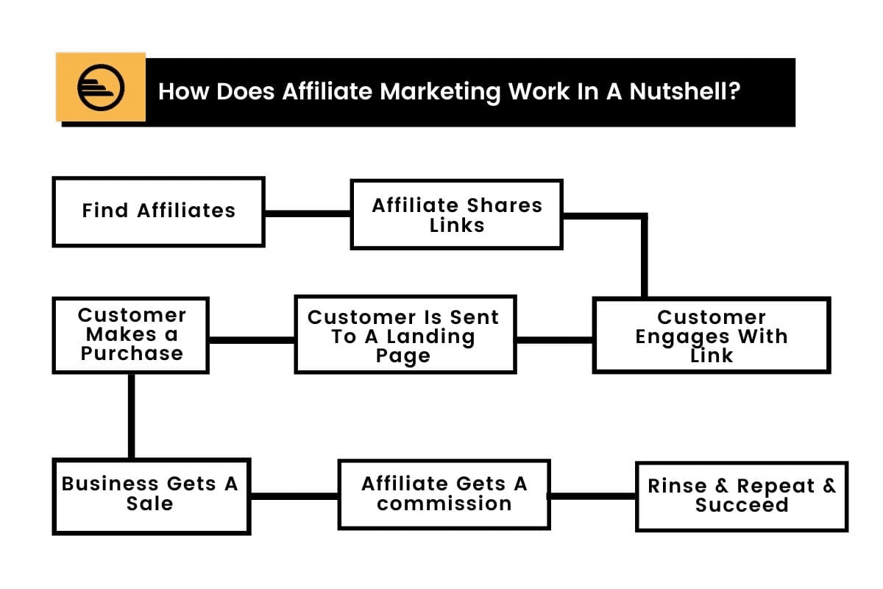How affiliate marketing works. (Source: Engaio Digital)
Affiliate marketers also sometimes promote products through social media, email lists, or videos.

Who Can Be an Affiliate Marketer?
Brands are looking for affiliates with a large reach. They’re trying to sell their products to your audience — so you have to have one.
Some affiliate programs require you to have a high-traffic website or influence in your field to become an affiliate.
Others will let anyone join, but you’re not going to be very successful if no one reads your blog, social media posts, or emails. The first step to becoming an affiliate marketer is to build an audience for your website.
If you already have a successful website, affiliate marketing can help you make money by doing a lot of the same stuff you were already doing.
You can even build an entire business out of affiliate marketing.

The Benefits of Affiliate Marketing
Why should you consider becoming an affiliate marketer? Is it really the best way to make money from your site?
Here are a few key benefits of getting into affiliate marketing.
It’s low-cost and low-risk: All you have to do is add some content and links to your site. Other than the cost of running the website itself, you don’t have to pay any money upfront. And if you never sell anything with your affiliate links, you don’t lose anything.
With time, you can build a steady stream of passive income without much investment.
The opportunities are wide-ranging: Whether your website is focused on cooking, travel, or software reviews, there’s an affiliate marketing program out there for you.
You can work from home: As earning income from the comfort of home becomes increasingly popular, so does affiliate marketing.
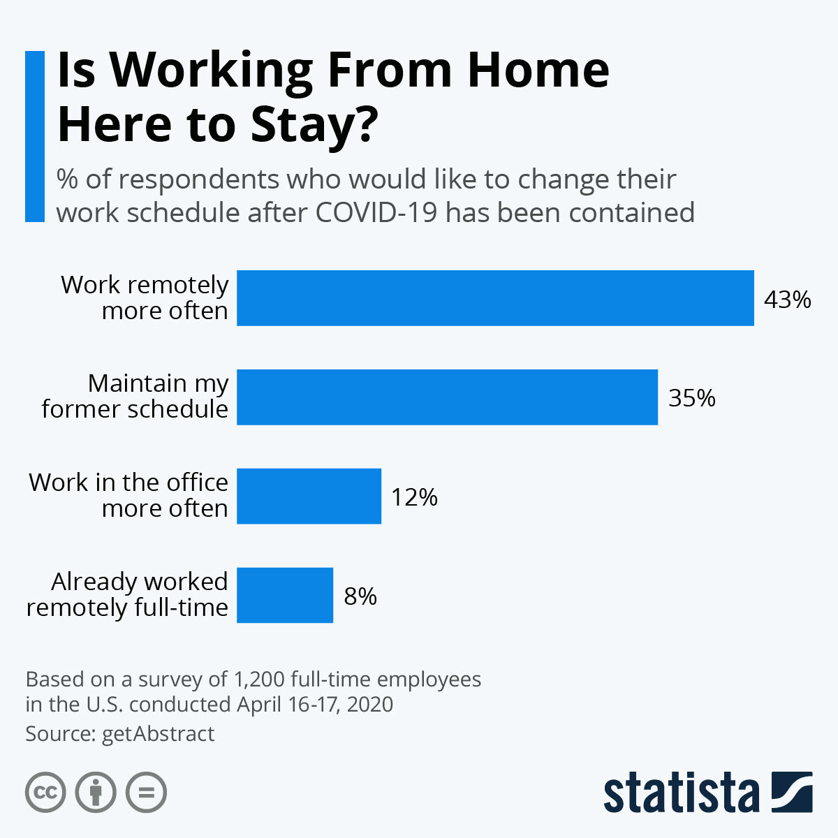The popularity of working from home. (Source: Statista)
Making money off of your website allows for a flexible schedule and lifestyle.
You don’t need to be an expert. You can become an affiliate marketer without any special knowledge or skills. Just try different ways of promoting affiliate products and see what works.
If you already have a blog, social media presence, or email list, you may already be doing a lot of the work. For example, you can just add a product review blog post to your regularly scheduled articles.
It’s lucrative. We’ll get into some income stats in a bit. Suffice it to say that affiliate marketers have the potential to make really good money.

Featured Affiliate Marketing Statistics and Trends
- The global affiliate marketing industry is worth over $17 billion
- Affiliate marketing is a top revenue source for 31% of publishers
- Affiliate marketing is the most successful channel for 20% of brand marketers
- 56% of affiliate programs increased revenue during the Covid-19 lockdown
- 81.2% of affiliate marketers make more than $20,000 annually

17 Affiliate Marketing Statistics
Let’s break down 17 affiliate marketing statistics.

1. The Global Affiliate Marketing Industry is Worth Over $17 Billion
The current global market size of affiliate marketing is over $17 billion. That’s up from $13 billion in 2016. The American affiliate marketing market alone is worth over $6 billion.

The Takeaway
Affiliate marketing is huge.
There’s a lot of money changing hands in the affiliate marketing world, and you can get in on it if you have a website with an audience.

2. Affiliate Marketing is a Top Revenue Source for 31% of Publishers
31% of publishers say that affiliate marketing is one of their top three sources of revenue. For 9%, it’s their top revenue source.

The Takeaway
Affiliate marketing is one of the best ways to monetize your content.
Unsurprisingly, in the same survey, 62% of publishers said that ecommerce is one of their top revenue sources.
Ecommerce and affiliate marketing are closely related, and the effort you put into one can help you make more money from the other. Both involve using your website or other marketing tactics to promote products.
The difference is that ecommerce involves selling your own products, while affiliate marketing involves selling someone else’s.

3. Affiliate Marketing Is the Most Successful Channel for 20% of Brand Marketers
Affiliate marketing is the most important customer acquisition channel for 20% of brand marketers. 54% rank it among their top three channels.
This is more than organic/paid search (16%) and display ads (15%).
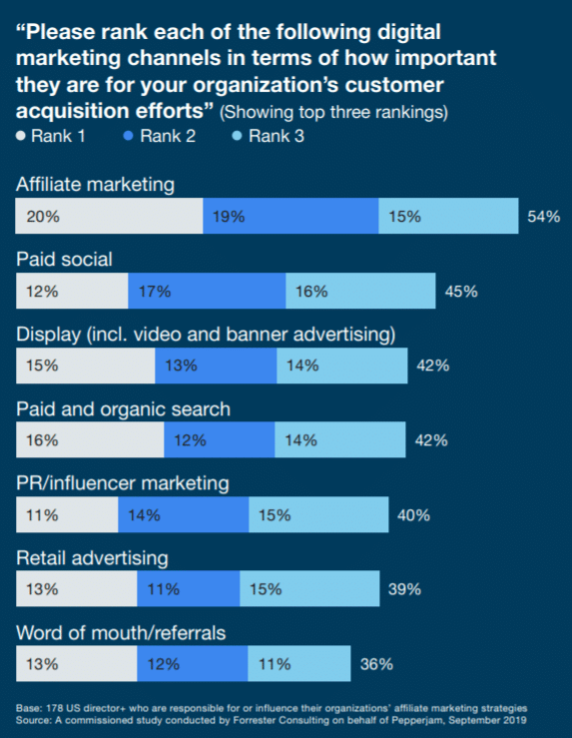The most successful channels for brand marketers. (Source: Pepperjam)

The Takeaway
Affiliate marketing is a mutually beneficial relationship. It’s a top revenue source for publishers and also for the brands whose products are being promoted.

4. Google Searches for “Affiliate Marketing” More Than Doubled Between 2015–2021
Google Trends shows us that monthly searches for affiliate marketing are on the rise.
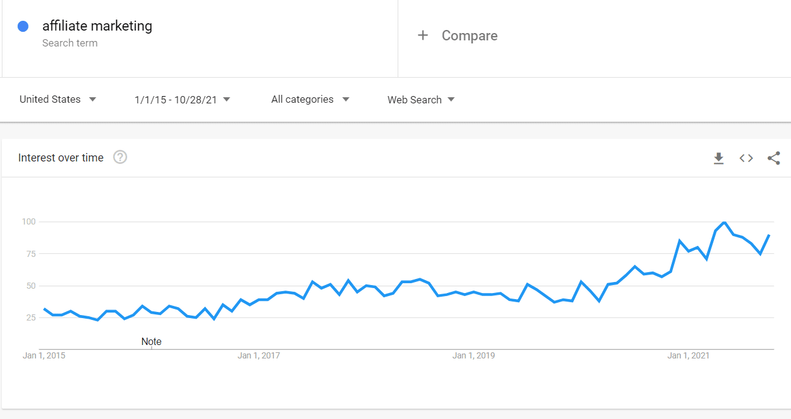Google searches for affiliate marketing since 2015. (Source: Google)

The Takeaway
Affiliate marketing is an increasingly popular way for publishers to monetize.
It’s not the only one, though.
Check out our list of 13 ways to monetize your blog. It includes tips on display advertising, paid membership plans, and selling ebooks.

5. “How To Create Content for Affiliate Marketing” is a Top Google Search
“How to Create Content Marketing” is one of the top 20 content marketing questions asked on Google.

The Takeaway
Content creators want to know how to make money through affiliate marketing.
If you’re one of the people searching this term, take a look at this list of affiliate marketing tips. The article references Kinsta’s affiliate system, but you can use the advice with any type of affiliate link.
Highlights include:
- Adding links and banners to your website’s footer and sidebar
- Writing reviews or sharing existing reviews
- Leveraging email and social media
- Writing a list-style blog and including the product in it
- Updating your old blog posts (where relevant) to include the product

6. 56% of Affiliate Programs Increased Revenue During the Covid-19 Lockdown
56% of affiliate advertisers and agencies increased their affiliate channel revenue starting in late March 2020.

The Takeaway
Ecommerce saw major growth during the pandemic. In 2019, online sales made up 16% of total retail sales. In 2020, that rose to 19%.
Affiliate marketing is no exception — over half of affiliate marketing programs increased their revenue during lockdown.
Many changes to consumer behavior are likely to continue beyond the pandemic. This is a great time to build your following and start earning money through affiliate marketing.

7. 19% of Affiliate Programs are in the Fashion Industry
The fashion industry dominates affiliate marketing, accounting for 19% of programs. In second place are sports and outdoor products at 15% and health and wellness at 11%.

The Takeaway
If you run a popular fashion website, you’ve got a lot of affiliate programs to choose from.
But that doesn’t mean you can’t be an affiliate marketer in a more obscure niche. All types of brands are looking for affiliates to spread the word about their products.
The easiest way to find affiliate programs in your industry of choice is simply to Google [product type] affiliate programs.
Here’s another tip: spy on your competitors. Look at sites similar to yours and see if they’ve posted any affiliate links.

8. The Toy Industry Saw 109% Growth in Affiliate Marketing Last Year
The fastest-growing product category for affiliate marketing is toys, with 109% growth in the last year. This is followed by software (103%) and home improvement (86%).
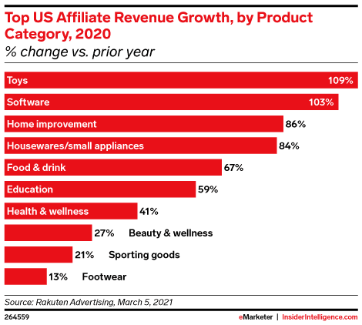Fastest growing affiliate product categories. (Source: eMarketer)

The Takeaway
Still looking for your niche?
There are a few industries, like toys and software, that are up and coming in the affiliate marketing world. These industries offer big opportunities to grow your revenue.

9. The Retail Sector Generates 43% of Affiliate Marketing Revenue
The highest share of affiliate marketing revenue comes from the retail industry, with 43%. After that is telecom and media with 24% and travel with 16%.

The Takeaway
Most of the big opportunities in affiliate marketing come from retail.
Some types of websites, like fashion blogs, have an obvious tie-in to retail. Other times, the connection isn’t as obvious. But you still might be able to find retail products to promote on your site.
Think about your typical audience and what type of products they might buy.

10. 59% of Companies use Influencers for Affiliate Marketing
Influencer marketing and affiliate marketing aren’t exactly the same thing. Many influencer marketing campaigns are about promoting brand awareness rather than just sales.
But 59% of brands and marketing agencies also use influencers as affiliates.

The Takeaway
Companies with affiliate programs are looking for affiliate marketers that have already gained the trust of a large audience. Sometimes that means influencers.
Being an influencer in the typical sense of the word isn’t a requirement for affiliate marketing, but you can take some sales hints from successful influencers in your niche.
Take a look at:
- What kind of content they create
- How they engage with their followers
- What keywords or hashtags they use on their website or social media

11. 88% of Consumers Have Been Inspired to Buy Something By an Influencer
88% of consumers say that they’ve decided to purchase an item based on what they saw from an influencer. A significant majority of both men (83%) and women (89%) have experienced this.

The Takeaway
You, too, can inspire your followers to buy a product.
Many consumers are open to product referrals. Build a following of shoppers that trust you, and you can be successful at promoting affiliate links.

12. 64% of Consumers Prefer Videos When Interacting with Influencer Content
When interacting with influencer content, 64% of consumers say that they prefer watching videos. Only 38% of consumers prefer written content. 61% of consumers say they prefer images.

The Takeaway
People love videos. Here’s another stat to back that up: the average person spends 2.5 hours per day watching videos online.
Consider promoting your affiliate links with video. For example, you can embed them on your blogs or landing pages or post them to social media.

13. 77% of Consumers Make Purchasing Decisions Based on Reviews
77% of consumers see customer reviews as a deal-breaker or deciding factor in their product purchase decision.

The Takeaway
Today’s consumers are savvy. They don’t just read an ad or product description and assume the product is great — they want to hear from real people who’ve tried it.
That’s why product reviews are one of the most effective ways to promote affiliate links.
Your review needs to be authentic. You’re not just promoting a product — you’re also establishing trust with your audience.
In addition to writing your own review for your website, you can use third-party reviews to give your recommendation more weight. Either link to these reviews (which may mean people won’t use your affiliate link to make a purchase) or get permission to embed or screenshot them.
If you’re part of the Kinsta affiliate program, you can link to our reviews landing page. That way, you can still use your affiliate link.

14. Amazon Associates Has 43% of the Affiliate Market Share
The Amazon Associate Program dominates the affiliate marketing space with a 43% market share.

The Takeaway
Amazon is the biggest player in the game.
Luckily, the Amazon Associate Program is also a lucrative program for many affiliates. The cool thing about it is that you can promote any of the millions of products on Amazon.
So, you can choose products that fit your niche and that you know your audience will love.

15. 99% of Affiliate Programs Offer a CPA Payment Model
There are several ways you might get paid as an affiliate marketer, but 99% of programs offer a CPA model.
CPA stands for cost-per-action. It means you get paid for each customer that takes a particular action, almost always a sale.
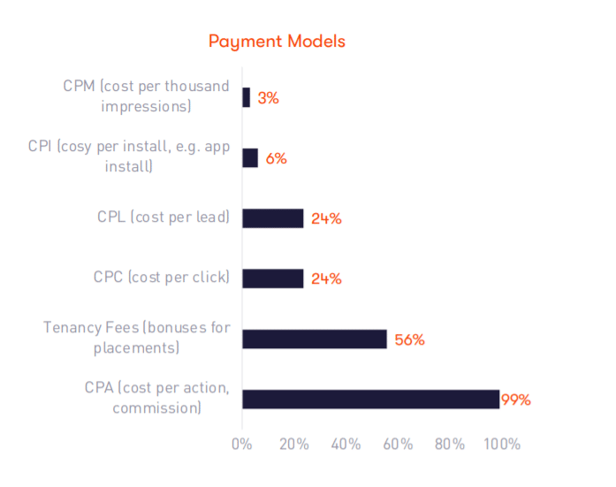Most common affiliate marketing payment models. (Source: IAB UK)

The Takeaway
If you become an affiliate marketer, you’ll most likely make an affiliate commission every time someone makes a purchase after following your affiliate link.
However, some programs offer other payment models as well.
For example, you could get paid for clicks of your link (CPC, or cost-per-click) rather than completed sales.

16. Some Affiliates Make Millions
Publishers who have released their income reports include Pat Flynn, who grew his business from $8,000–$100,000 per month, and Adam Enfroy, who makes $200,000 per month.

The Takeaway
Some affiliate marketers have extremely successful careers. Will you be the next affiliate marketing millionaire?

17. 81.2% of Affiliate Marketers Say They Make More Than $20,000 Annually
According to a survey of STM forum users, 81.2% of affiliate marketers are making over $20,000 per year.
Quite a few claim to be making millions.
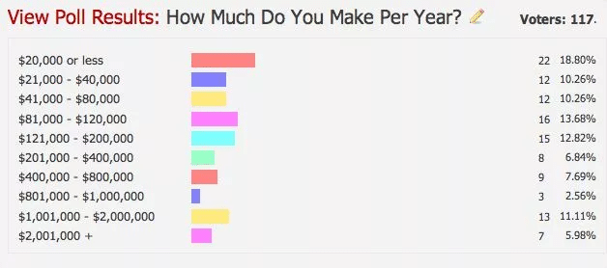Affiliate marketer income poll. (Source: Affise)

The Takeaway
STM Forum is a popular online community of affiliate marketers that requires a paid membership.
In other words, most people on the forum are experienced affiliates who are serious about making money through affiliate marketing.
That’s going to skew the results of this survey a little.
Still, the fact remains that a lot of people are making a decent income by becoming affiliate marketers. As affiliate marketing grows, the opportunity is there for you to be one of them.

Trend Forecasts: Affiliate Marketing in 2021–2022
You’re thinking about getting into affiliate marketing. But what does the future of an affiliate look like?
Will the affiliate marketing trends reflected in the stats above continue? Is affiliate marketing still worth it?
Here’s what we can expect from affiliate marketing in the year ahead.

Affiliate Marketing Will Continue to Grow
Both affiliate marketing and ecommerce, in general, are on the upswing, and that’s unlikely to stop anytime soon.
More people than ever are shopping online, and brands will increasingly turn to networks of affiliates to sell their products. Consequently, more affiliate marketing programs will be available each year.

Influencers Will Take on a Bigger Role
You saw stat number 11 above — influencers are very successful at convincing people to buy products.
Influencers have a big following and are seen as trustworthy and knowledgeable by their audiences. More affiliate programs will take advantage of that and use influencers as affiliates.

Affiliate Marketers Will Focus More on Seasonal Sales
You’ve definitely heard of holiday specials based around Christmas or Thanksgiving. But what about National Cat Day or National Cheesecake Day?
Customers respond well to deals based around these fun “holidays” as well as the more traditional ones, and online retailers are increasingly taking advantage of that.
The trend is spilling into affiliate marketing, too, with more affiliate marketers focusing on campaigns aimed at specific events or seasons.

There Will Be More Affiliate Programs Based on Subscriptions
What’s better than earning one commission from a sale? How about getting recurring payments?
There are more and more affiliate programs for subscription-based products and services. As an affiliate publisher, you’ll have more opportunities to join these in the future.

Fewer Third-Party Cookies Will Be Used
Affiliate programs have historically used third-party cookies to track successful conversions. But Google Chrome and other browsers are in the process of phasing these cookies out.
Affiliate programs will have to move to other methods of tracking in the near future.

Summary
Affiliate marketing is one of the best ways to monetize your website — and the opportunities to be an affiliate are only going to grow in the future.
Of course, Kinsta is always looking for more affiliate marketers for our affiliate network. Find out if you qualify here.
Want to jumpstart your affiliate marketing career with in-depth guides, affiliate marketing strategy, and insider tips from the top affiliate marketers in the industry?
Join the Affiliate Academy.

Power your site with Kinsta’s Managed WordPress hosting, crafted for speed, security, and simplicity. With Kinsta, you get:
- Effortless control in the MyKinsta dashboard
- Unlimited free migrations, handled by our expert migrations team
- 24/7/365 support from WordPress experts
- Powerful cloud infrastructure and cutting-edge servers
- Enterprise-grade security through Cloudflare integration
- Global reach with 30 data centers

